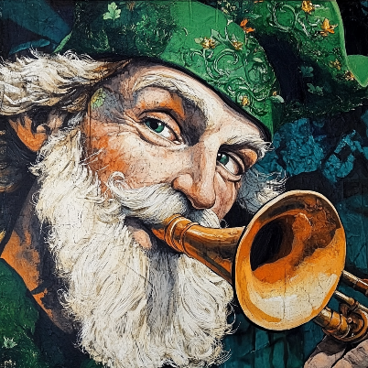

Happenings

Heritage

# March 2025

The monthly newsletter published by residents of  
Heritage on the Marina, San Francisco CA, USA

# This month it’s Ireland

 The country of the month is **Ireland**. The masthead cameo highlights Saint Patrick blowing a traditional Irish horn. He appears to have blessed many residents with the “gift of the gab”: numerous new contributors shared their precious wisdom.

## New Residents

Candy and Jim Naughton moved from Marin into 411 & 420 Perry. Candy says, “I was taller than Jim back in seventh grade.”

## Events of Interest

* Mardi Gras Dinner 3/4
* Daylight Savings 3/9
* Semiannual Meeting 3/12
* Birthday Night 3/14
* St Patrick's Day Dinner 3/17
* Centenary Celebration 3/27
* Residents Council 3/28

## Landmark Designation

In January the San Francisco Board of Supervisors voted unanimously to register the Julia Morgan Building as a Historic Landmark.

## Centenary Celebration

Heritage on the Marina is celebrating the centenary of the opening of the Julia Morgan Building on March 27. A gala celebration is planned. Numerous local dignitaries will attend. A new bronze plaque imparting the details of the Landmark designation will be unveiled. This is a fundraising event and sponsorship is welcome. Phone 415 202-0103

## Article in SF Heritage News

The centenary of the Julia Morgan Building is a major article on page 3 of the January  
[San Francisco Heritage Society newsletter](https://www.sfheritage.org/wp-content/uploads/2025/02/Jan-Mar_2025_Newsletter_FINAL_web.pdf).

## San Francisco Ladies Protection and Relief Society featured in its own Wikipedia Article

Theo Armour has at last submitted his article on the San Francisco Ladies Protection and Relief Society to Wikipedia. Here is the link:  
<https://en.wikipedia.org/wiki/San_Francisco_Ladies_Protection_and_Relief_Society>

The article is work-in-progress. Many corrections and much new information are waiting to be added. New articles on Heritage on the Marina and the Julia Morgan Building are in the making.

## Centenary Exhibit: Art Gallery

Coretta Scott King said: *The greatness of a community is most accurately measured by the compassionate actions of its members*.

The 100th Anniversary event will celebrate the Morgan building, its designer Julia Morgan, the beauty of the building and its historical value. The display in the Tony Lawrence Gallery, through photographs, art projects and words, will emphasize that the essential benefit of this building is truly measured by the power of our communal life, fed daily with active love, friendship and compassion.

## Author’s Reading

June Fraps’ cousin Laura Burges reads from her new book: ***Wisdom Stories of Tibet*** on March 6 at 3 pm in Friendship Hall. Members of Next Village, the popular seniors organization, are invited to attend.

## QR Codes

The funny box on the left is called a QR Code. If you take a photo of a QR code with your phone a link will pop up. Clicking on the link above will take you directly to the new Wikipedia article. QR codes help you get to web sites without a lot of typing. Thanks to Tom King for the typically topical tip.

## Emergency Contact Info

Here is what you should have as the emergency contact that appears on your phone or in a message in your wallet:

*Resident of Heritage on the Marina  
3400 Laguna Street,  
San Francisco, CA 94123*

*In emergency, please notify   
Front Office: 415-202-0300*

*After hours Manager on Duty:*

*628-789-2218*

## Job Opening

Tom and Theo have set up a workspace for scanning the important historical documents in the Stucky Library. We are looking for a resident who is willing to learn how to scan documents using the professional book scanning device recently acquired by Tom. The pay is $25 per hour.

## March Madness Basketball Pool

The Heritage basketball pool will start in the first week of March 2025. You don’t need any expertise or knowledge of basketball.

Each square costs $5 and put the money in the envelope next to the form. You can buy squares for anybody you like, and relatives and friends can also buy squares. However, no member of the staff can buy squares, and you cannot buy squares for any member of the staff.

The March Madness finals will be held in early April, and we can determine our winner immediately after the game.

If all squares are sold $500 will be raised of which 60% goes to employee appreciation and 40% goes to the person who bought the winning square.

**Please write your name clearly.**

## Need Company?

There are several residents who accompany others to their medical appointments to provide helpful support. Val Szigeti is joining the ranks of these volunteers, so please get in touch with her if an escort to an outside engagement would be useful to you.

## Garden Committee

The Garden Committee plans to plant a plum tree in honor of Kay Narron. They will meet with Hector about this along with filling the space where the camellias used to be.

|  |  |
| --- | --- |
| Heritage Happenings The monthly publication published by residents of  [Heritage on the Marina](https://heritageonthemarina.org/) Editor Emerita Margaret Jacobs Editor Theo Armour Associate Editor Mia Cotton Harlock Editorial Committee Jane Standing  Martha Nell Beatty  Doris Howard Tom King Margaret Missiaen Reporter at Large Trish Otstott Proofreader Midge Mansouri Website [heritage- happenings.github.io](https://heritage-happenings.github.io) General Disclaimer The views and opinions expressed in this publication are those of the authors and do not necessarily reflect the official policy or position of Heritage on the Marina.  © 2025 Heritage Happenings authors.  No rights reserved. | Leadership Communications Recently the Heritage on the Marina Leadership Team distributed to residents two documents worth highlighting. The January Financial Meeting with Residents document states quite clearly the rationale for the San Francisco Ladies Protection and Relief Society — always a 501(c)(3) — returning to being “public charity” after several years of being a “private foundation”.  Oral discussions at length in multiple meetings resulted in some confusion. The written document records, clarifies and solidifies the positive intentions of the BoD.  In February we received Leadership Update Meeting Minutes. The document clearly details the accomplishments of all the departments. In particular, it also captures the multiple residents’ questions and observations along with the responses from the Leadership Team.  The documents are available from the Front Office. The documents are not perfect. From my eyes they could use some good editing. ;-)  Nonetheless, the documents indicate a positive momentum in communication with residents that is comprehensive, detailed and accessible to all at any time. Perhaps the Leadership Team is also blessed with the “gift of the gab”!  *Theo Armour* |

# Leadership Updates

## Board of Directors

The Board of Directors is in the process of putting together a complete and honest description of who we are and who we serve. The plan is to approach a pre-selected group of similar nonprofit senior communities to see if there is a mutual fit for affiliation. At this point the board has not yet contacted any outside community.

## Accounting

The 2024 actuarial study and 2024 audit have started. We are providing data for the auditors to help bring us current.

The new accounting system Yardi is coming online. There will be a resident portal in Yardi called RentCafe — aiming to improve the overall Heritage on the Marina experience for both residents and staff by offering a range of digital tools and services. We may upgrade the webpage to have this service all in one place.

The next system to come online will be the Electronic Health Record and Medication Management. Training has been going on this month for nursing staff. The pricing update for Aging-in-Place is completed and in final review.

## Human Resources

Recruiting updates

* Four nursing positions
* Lead Maintenance position

## Resident Health

Collaboration with Earl Bowen Center for the Blind: we are coordinating a discussion about their services.

Calling 911 versus taxi rides to the ER: we may bring in an ambulance company to come and talk to us about this, if residents see the need.

## Dining Services

Thank you for understanding the egg shortage! BTW, did you know that all eggs served here are pasteurized — including eggs in their shells?

## Facilities

* Chair lifts have been installed on staircases in both Morgan & Perry
* Nursing calls and general annunciator systems are being installed
* Many fixes and upgrades in the parking lot have been completed
* Work continues on numerous apartments

## Housekeeping & Transport

* Van coolant and wheelchair lift repairs completed
* BoD is looking into getting a new van

# Nourish to Flourish: Eating Well & Staying Hydrated

By Mia Cotton Harlock

To eat is a necessity, but to eat intelligently is an art  
— François de La Rochefoucauld

While staying healthy is a full-time job, it doesn’t have to be a grind. Eating well and staying hydrated are some of the most satisfying, sensual, life-and-spirit enhancing habits to adopt — though for many of you, we’re probably preaching to the converted!

*We interrupt the regular program:*

# Trish’s Contribution

The brain continues to be a mystery. The neurologists at UCSF still cannot answer every question about this vital organ.

I have been reading a bit about brain health, as my husband, Dick, and I (luckily) continue to age. I thought I should share some of my notes with you before I forget!

Our brains process information at about 268 miles per hour, so fuel is important.

## Foods that power your brain

**Salmon**: omega 3 fatty acids lower the risk of depression

* **Eggs**: protein and nutrients promote better memory and communication
* **Blueberries**: bursting with antioxidants that stimulate the flow of blood and oxygen in the brain. Sometimes referred to as “America’s super food.”
* **Leafy Greens**: for Vitamin E (delays cognitive decline), Vitamin K (sharpens memory).

Dick and his golf buddy have vowed to never eat anything green, so this one is a constant challenge.

* **Nuts**: walnuts help counteract cognitive decline, almonds help improve memory, pistachios help prevent inflammation
* **Coffee**: (such good news!) Blocks adenosine, a chemical that makes you tired
* **Chocolate**: (more good news!) Dark chocolate provides antioxidants to the brain

## Foods that can impair your brain functions

* **Processed foods**: (oh no, our favorite snacks!) chips, cookies, and sugary drinks
* **Trans fats**:  found in shortening, margarine, frosting, snack foods, and prepackaged cookies
* **Artificial sweeteners**: aspartame, saccharin, and sucralose, found in diet sodas and sugar-free gum
* **High-sodium foods**: can contribute to poor brain health
* **Red and processed meats**: excessive consumption can reduce cognitive function

Dick is from Texas and loves to grill steaks – this one hurts.

Well, these are my notes as a quick reference for brain foods. Luckily, Heritage on the Marina Dining Services is well aware and provides y’all with good food and good food choices.

**By roving reporter Trish Otstott**

## Mindful Sips ~ Hydration Helps

While there are countless reasons to drink up, we’ve room for just five, so here goes:

1. Maintains your energy levels
2. Improves brain function
3. Supports joint health
4. Aids in digestion
5. Helps prevent (painful!) urinary tract infections

While eight cups (64 ounces) of water a day should be your general goal, it really depends on your body’s needs, health, and activity level.

Did you know that as we get older, our thirst signals can become quieter, making us more prone to dehydration? Also, factors like medications, health conditions, and changes to our metabolism can influence how much water we need. That said, keep an eye on your hydration. Set yourself a reminder to sip that glass of water — ice or no ice — every meal!

## Overheard in the Dining Room

Dining staff asked: “Are you having any guests for dinner?”

Resident who is a bit hard of hearing: “If that’s what you’re serving, that’s what I’ll eat.”  
❧  
Bob B: “Irish Coffee is the drink that contains the four major food groups: sugar, coffee, cream and whisky.”  
❧  
Marty talking with Ian Paisley, Northern Ireland Protestant hothead and firebrand. Ian asks Marty, “Would you like to come over to my house for a cup of tea?”

## Indulge — in Moderation

Fear not, there will be no depriving yourself (unless your doctor insists). Eating well doesn’t mean subsisting on kale salads, nuts, and berries 24/7. Small indulgences are encouraged! — in moderation. Even out that decadent dessert with a nourishing breakfast.

Let’s toast with a few sips of wine and a full glass of water to eating well and staying hydrated!

# Gently Down the Stream of Irish Consciousness

By Tucker Ingham

The expression "a stream of consciousness" is Irish, and made known by its creator, James Joyce, through his two books, *Ulysses* and *Finnegans Wake*. Both books explore Irish culture in the early 20th century, though they were written by Joyce in Paris more than twenty years after he left Ireland, never to return. Joyce brought with him his recent girlfriend, whom he refused to marry, while they raised two daughters in penury, drifting around Europe, teaching school and writing short articles from 1904 to 1920, when persuaded by Ezra Pound to move to Paris along with Ernest Hemingway, F Scott Fitzgerald, and other notable authors.

Sylvia Beach, proprietor of the Left Bank Shakespeare and Company bookstore, in 1922 risked publishing *Ulysses* but lost her investment, as the book failed to succeed on the market. Its language was contrived and cryptic, its message unintelligible. A judge called upon to censor, declared it obscure and emetic, but not prurient. Perhaps because of its public failure, many copies were burned by postal authorities as undeliverable.

By 1933, Joyce was almost blind but still determined to make his mark as an intellectual author. By 1941, he'd finished *Finnegans Wake* (no apostrophe purposely), where he took obscurity to an extreme. People assumed that its baffling style indicated secret knowledge. Two hundred sixty pounds of his notes produced 628 pages of a book. "More noted than read and when read, only partly and rarely understood by anyone ... notoriously the most obscure book ever written by a major writer, at least one who was not known to be out of his mind." — Daniel Boorstin, *The Creators*, Chapter 68

# A grave stone with a statue of a person and a child AI-generated content may be incorrect.Patti Gallagher’s 2008 Irish Vacation

In June of 2008, I treated myself to a “Wayfarers Walking Vacation” in Ireland. I had longed to return to Ireland since 1976, when I attended a two-week summer course on Irish literature at Galway University and afterwards traveled all over the country for three weeks. 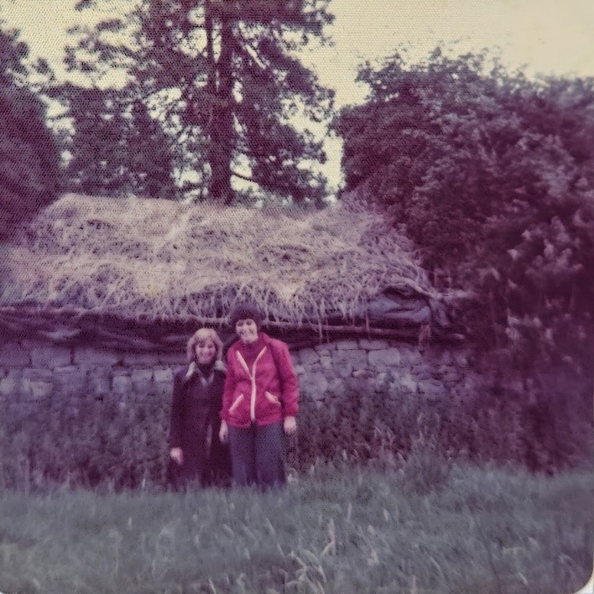  
I met distant relatives, visited the stone, thatched cottage where my grandmother, Rose Ann Wynne, was born, and the cemetery where my grandmother’s relatives were buried. I had wanted to return to Ireland for years, but LIFE got in my way, and I did not have another opportunity until 2008.

The Wayfarer’s Walk was titled “The Ring of Kerry – Celtic Pride and Irish Hospitality.” The Wayfarers have been leading walking vacations all over the world since 1984 and they do an amazing job. Since 2008, I have been on three more Wayfarers walks in England.

This walk was five days, six nights, which began and ended in the city of Killarney. Our group of seven stayed at beautiful hotels and inns, where we were served breakfast before walking 7-12 miles each day. Two hours into our walk the Wayfarers van would meet us, provide drinks and snacks and give us a menu for the pub or restaurant where we would be stopping for lunch. We would select our meal, which would be ready and waiting for us when we arrived.

After lunch we would walk to the destination where we would have a delicious dinner and spend the night. The van took our luggage from one hotel/inn to another whenever we changed locations for the night. So, basically all our group, led by our fearless, funny, entertaining and very patient walk leader, Alan Pinkney, had do was eat, walk, eat, walk, freshen up and rest before dinner, have dinner, followed by entertainment, (traditional Irish music, story-telling, Irish dancing), or just hanging out in a local pub, get a good night’s sleep and start all over again in the morning!!

We walked over beautiful heather-covered or emerald rolling hills, on ancient drovers’ trails, into primeval forests, on wild beaches and beside gorgeous lakes and waterfalls. Throughout each day, Alan entertained and educated us with lessons in Celtic history, culture, geography, flora and fauna, Irish literature, politics and folklore.

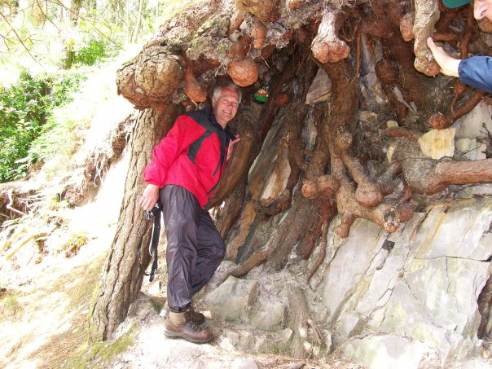One day we walked for hours in what truly felt like a magical, mystical forest. Alan, who kept running ahead of the group and disappearing into the woods, had said at the beginning of the walk “if we don’t see a leprechaun today, we probably never will.” Eventually we came upon a very ancient tree whose roots were exposed and hanging down the side of a hill. Alan was standing inside the tree’s roots and when I looked up, I saw a leprechaun above him! 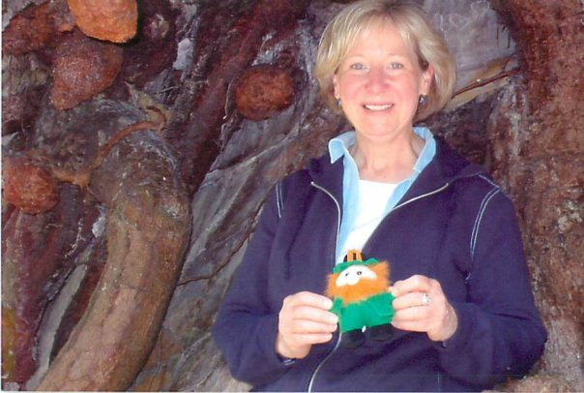Since I was the one who discovered the leprechaun, I got to keep him as a prize! That little fellow, whom I named “Shenanigan MacGillycuddy” (after “MacGillycuddy Reeks,” a mountain range above Kenmare, Ireland) became my good luck charm and has been my traveling companion ever since! I never get on an airplane or take a road trip without Shenanigan.

In 2019, I became an Irish citizen, so I now have dual citizenship!

# *Erin go bragh!*

# An Irish Business Trip

By Tom King

In the early 1980s, our company had two operations in Ireland, a manufacturing facility in Waterford next to the famous glass factory, and a software engineering facility in Cork about 125 km away. Arriving one evening in Waterford, I had dinner at a reputedly fine restaurant after which I was looking forward to some jet-lag recovery. The wine steward pretended to be French, complete with a phonied-up accent, even though he was as Irish as the day is long. The meal came with a side of potatoes — fixed six different ways (au gratin, mashed, baked, and a few others), so I knew I was in Ireland.

The next morning after my meetings with the manufacturing folks, I asked the manager, Paddy McCarthy, for directions to Cork, since I planned to drive there the following day. His complex directions included many right and left turns with landmarks in place of street names; I dutifully wrote this all down.

Commencing in the pre-dawn darkness of a rainy next day (the hotel receptionist said, “Tis a soft mornin”) and driving on the left side of the road in a car whose controls were strangely all on the right, I made quick progress on the deserted highway until I caught a glimpse of a dark mass in the middle of the left lane a kilometer or so ahead. Closing rapidly, I was dismayed to see that the mass hadn’t moved, so I endeavored to swerve around it. Performing this evasion caused the car to slide unexpectedly.

Catching the slide, I made it around what turned out to be a large pile of sweet potatoes whose dirt had spawned the muddy slime that had oozed across the road in this soft mornin’. Whee! Irish farmers own their roads.

Entering the rather large town of Cork, I followed Paddy’s instructions faithfully only to find myself lost. Returning to my original entrance into the town, I more diligently followed the written instructions in those pre-Google, pre-GPS days. This time, I became lost in the same manner. By then, I was in the rush hour traffic I had hoped to avoid, and so, puzzled and now somewhat distrustful of my own note taking abilities, I thought I might switch one or more of the instructions from right to left or vice versa. However, no combination of directional reversals yielded any better results, and, with no cell phones in those days and no likely pedestrians to accost with my idiot colonist questions, I threw up my hands and decided to reverse EVERY right and left. That tactic took me directly to my destination, the Cork software engineering facility. Pulling in there, I was blocked by a police officer who told me the Taoiseach (i.e., the prime minister of Ireland) was visiting and so I needed to park elsewhere. The police officer was nice enough to tell me there was a parking area just down the road three hundred meters through a gate on the right. I drove 300 meters down the road and turned left through a gate into the parking area.

When I met with the English director of the software engineering group and told him of my directional misadventures, he said, “Paddy’s a Corkman.” I said, “So what?” The director said, “It’s well known that Corkmen don’t know their right from their left.”

# EPIC in Dublin

By Martha Nell Beatty

EPIC — the Irish Emigration Museum is a worthy addition to a Dublin itinerary. Opened in 2016, the Museum’s 20 interactive galleries immerse you in the Irish diaspora and the influence Irish emigrants have had around the world through the centuries. And very importantly in America. After all, eleven US presidents had roots in Ireland — JFK, of course, was there and always the surprise — Obama, with his Irish ancestry.

There’s something for everyone. All ages and you don’t have to be of Irish ancestry. There are touchscreens, immersive video installations, interactive games, interactive maps.

We didn’t allow nearly enough time for EPIC because The Museum also has a digital genealogy center, Irish Family History Centre, where one can trace one’s Irish ancestry.

Knowing my paternal grand-mother’s parents were from Northern Ireland, I wanted to search the records with the help of my daughter Alana.

One item we uncovered truly surprised me. It was the marriage license of my grandparents in 1884 in “Napa City.” Almost the same year the San Francisco Victorian I lived in was built.

# Northern Ireland

By Nancy Ozsogomonyan

During the year that I was a college student in Paris, 1963-64, my roommate, Debbie, and I decided to spend our three-week spring break in the UK and Ireland, hitch-hiking and staying in youth hostels.

One memorable exception to the youth hostels occurred in Northern Ireland, where we spent a night in the home of friends of my maternal grandmother, who was born and raised in a tiny hamlet near Cookstown. My mother had arranged the stay and provided directions.

We arrived in the afternoon and were welcomed with a cup of tea and a tour of the family’s veterinary practice. Then we were guided on a walk through the village, where the few inhabitants had obviously been told to expect us. We met most of the people of the town before continuing to the church, where we were shown the organ that my great-uncle from Philadelphia had donated. Back home, we had a delicious dinner, followed by music and stories.

I remember well the sleeping arrangements. The beds were high, requiring a step stool to access. We were provided with a container of hot coals in the bed to keep us warm. The next morning, we had a very tasty breakfast, highlighted by scones, eggs and bacon. Soon afterwards, we continued our journey west and then south.

# Donuts in Yosemite

By Tony Hanley

My grandparents, Bridget and John Degnan immigrated from Ireland to the United States in 1883. They eventually moved to Yosemite. John built a house. Bridget began to bake bread and sold it from their front porch. She then added meals for sale. Over time the family added a restaurant, store, and bakery.  
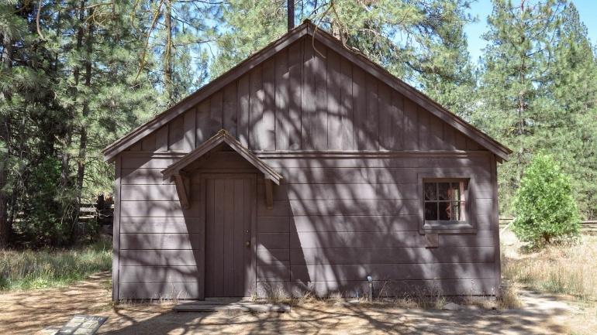I used to spend my summers in Yosemite and when I was eight years old, I used to get up early to help the baker. My job was to bring the donuts from the bakery to the store. By the time I reached the store, two donuts would be missing and when I had finished at least six donuts never made the shelf.

# A tree in a park AI-generated content may be incorrect.Ireland October 2017

By Nancy Trogman

*An excerpt from my 2017 diary:*“We left our hotel a little early Monday morning heading for Galway, with our final destination being Limerick. We didn’t make it to Galway, as all stores were closing, all schools and universities across the country were closed as well as today.

There were 240,000 without power and I’m hearing water plants are also closed because of no electricity. I think most is in the south around Cork. Three people were killed.

We went directly to our hotel in Limerick. Our bus was being pushed by the winds. We actually only had winds. Everyone was told to stay in. The hotel put together a buffet lunch for us and the tour company paid. The bar was open…

Today we got back on track. First stop was Bunratty Castle, originally built in 1425 and has been renovated. We then drove to the Cliffs of Moher at the Atlantic edge. A beautiful, rugged coastline.”

# One Man’s Pass at Slieve League

By Patrick Alexander

My father and his three brothers were staying in Killybegs on the west coast of Ireland in Donegal.

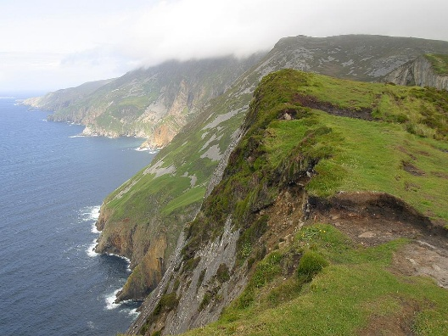This was a few years before the First World War and my father, being the youngest of the four brothers, was in his late teen years. He told the story of how the brothers planned to visit the cliffs at Slieve League and walk the One Man’s Pass. My father always referred to that pass as “The Dead Man’s Pass”.

So, leaving the hotel at Killybegs, my father and his brothers drove to the closest point you could get to in order to walk along the pass. The trip took about 45 minutes, and a huge storm was brewing in the Atlantic. When they arrived, it had started to rain. But it always rains in Ireland and especially on the West Coast, so they paid no attention to that. The four of them then set out to walk the pass. The pass is a narrow knife-edge footpath literally along the top of the mountain with sheer drops either side. The rain was pelting down, and huge waves were crashing against the cliffs 2,000 feet below. The cliffs are some of the highest in Europe, and my father said you could not tell whether it was rainwater or ocean spray that you were being soaked with. The waves were so big and powerful that the whole mountain seemed to tremble when they struck.

Eventually my father and his three brothers managed to walk the pass, which is about 3 km long, and return to their car. The experience left my father with a great respect for the power of nature.

In my teenage years my brother and I went with one of our uncles to stay at Bundoran, in County Donegal which is not far from Killybegs. We did visit Killybegs, but my uncle was very reluctant to walk the “Dead Man’s Pass” again. So, we never did.

# My Second Visit to Ireland in 2008

By Sheila Moore

Visiting Ireland is a delightful experience — pubs are found all over! The landscape is filled with lush green meadows and sheep everywhere. Sheep and pubs! And, of course, Guinness!

Ireland is abundant with flocks of sheep, and its vibrant greenery is due to the frequent rainfall.

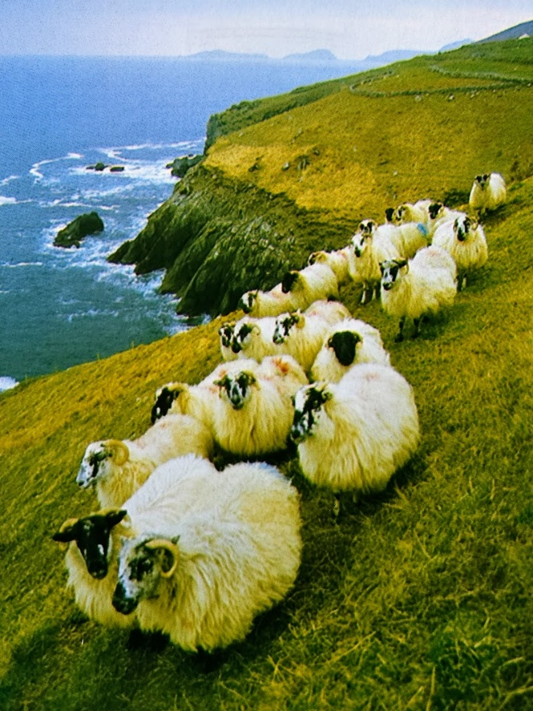

The Giant's Causeway along the Northern Antrim Coast features stones that are all hexagonal, forming these unique formations.

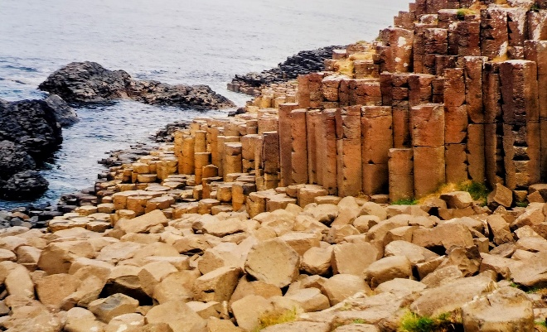 Kissing the Blarney Stone at Blarney Castle! You lie back and kiss the stone. This grants you "The Gift of The Gab," making you charmingly talkative!

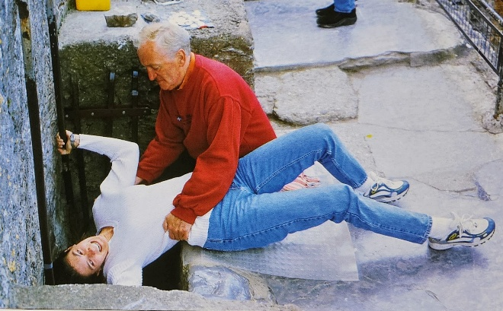

These Irish pubs are everywhere!

# Library Corner New Acquisition February 2025

By Martha Nell Beatty

***The Code Breaker: Jennifer Doudna, Gene Editing and the Future of the Human Race* ~ NF ~ 2022**by Walter IsaacsonThe bestselling author of *Leonardo da Vinci* and *Steve Jobs* returns with a “compelling” account of how Nobel Prize winner Jennifer Doudna and her colleagues launched a revolution that will allow us to cure diseases, fend off viruses, and have healthier babies.

# Heritage Book Club

By Margaret Missiaen

The Heritage Book Club meets on the second Saturday of each month to discuss a book chosen by the members. New members are always welcome. Come with a list of books you have read or would like to read. Our selection for March is *The Bad-ass Librarians of Timbuktu* by Joshua Hammer. We will meet in the cottage at 11 am on March 8 followed by lunch in the dining room. You do not have to finish the book to join in the discussion.

# Cooby Reminds

To Eire is human.

# Yvonne Recommends

Irish Author Claire Keegan writes novellas about Ireland, which are pretty much true stories. Her latest novella is *Small Things Like These* — a deeply moving story of everyday people living in Ireland back in the 50's and 60's.

# Pam B remembers

In the office I used to work in, whenever there was a tiff between staff members, an Irish colleague of ours would walk around the office gently waving a yellow card — the symbol of a penalty in soccer.

# Til Warns

I did go to Ireland and visited the Blarney Castle, but I did not kiss the Blarney Stone because I didn't know what germs it had on it, and you had to bend way over backwards to get to it.

# Why Pollard Trees

By Margaret Missiaen

The trees planted near Heritage on the Marina on Laguna, Francisco and Chestnut streets are London plane trees. On most of the trees, the bark peels away to show a cream-colored inner bark. The bright green leaves are similar to those of the maple, but larger.

Characteristics of the trees show a great deal of variation because they are hybrids, which are often mistaken for one of the parents, the American sycamore (*Platanus occidentalis*) or the Asian planetree (*Platanus orientalis*).

Along streets these large specimens can cause problems by reducing visibility, blocking drains and lifting pavement. One way of managing this is to pollard them and it is better than removing them.

Pollarding involves cutting back the branches of a tree to a point, known as the “pollard head”. This is usually done when the tree is dormant to minimize the stress on the tree. The pollard head will grow new shoots, which will form the new branches of the tree. It is a common practice in urban areas, where trees are often planted in small spaces and need to be kept under control. Recently, I found arborists pollarding the trees on Laguna.

# Walking Group

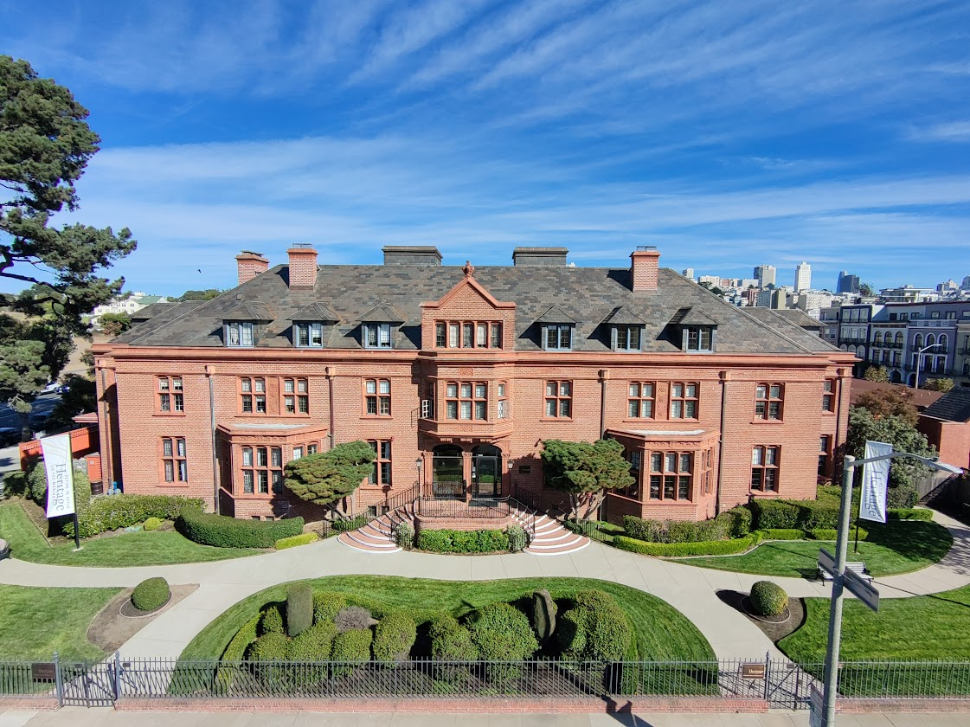

### Julia Morgan Building

